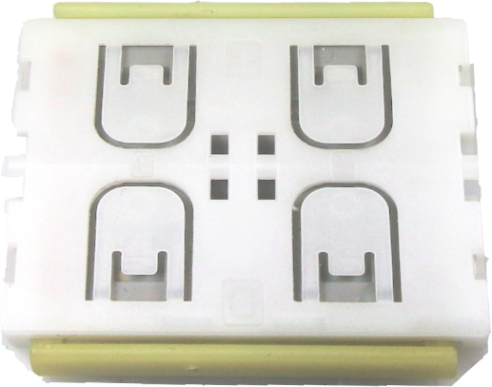
Pushbutton transmitter modules (PTM) from EnOcean enable the implementation of wireless remote controls without batteries. Power is provided by a built-in electro-dynamic power generator.
Features overview

Power supply power generation by rocker movement
via electro-dynamic power generator
Antenna integrated PCB antenna
Frequency 868.300 MHz / 902.875 MHz / 928.35 MHz
Data rate 125 kbps
Channels 2 with 4 action states each (upper/lower/pressed/released)

EnOcean Equipment Profile supported F6-02-xx, F6-04-xx (normal mode)
D2-03-00 (secure mode)

Transmission range 300 m free field (PTM 215J: 200m), typ. 30 m indoor
Energy bow travel/Operating force 1.8 mm / typ. 9 N (at room temperature)
Number of operations at 25°C typ. 100.000 actuations tested according to EN 60669 / VDE 0632
Module dimensions (inclusive rotation axis and energy bow) 40.0 x 40.0 x 11.2 mm
Operating temperature - 25 up to + 65 °C
Radio approvals R&TTE / EN 300 220 (PTM 210 / 215)
IC/FCC CFR-47 Part 15 (PTM 215U)
ARIB STD-T108 (PTM 215J)

Radio signals are event controlled (press / release) with button code and unique module identification (fix 32 bit ID, PTM 215J 48 bit possible).

Key applications are wall-mounted flat rocker switches with 1 or 2 rockers (with medial position), as well as handheld remote controls with up to 4 single pushbuttons

Functional Principle

The electro-dynamic energy transducer is actuated by a bow, which can be pushed from outside the module on the left or right by an appropriate pushbutton or switch rocker. When the energy bow is pushed down, electrical energy is harvested and a RF telegram is transmitted including the module ID.

PTM telegram contains the information that the bow was pressed or released. In addition, the radio telegram transmits the operating status of 4 contact nipples when activating the bow. This enables the identification of up to 2 appropriate switch rockers or up to 4 single pushbuttons.

By measurement of the time between push and release telegram, the receiver can easily implement applications dimming or shutter control.

An additional encryption mode can be activated. Telegrams are encrypted via a combination of rolling code and AES128 algorithm.

The PTM 215 include an additional NFC Interface for commissioning via a NFC capable smartphone or PC application.

Type  PTM 215  PTM 215U  PTM 215J  PTM 210 | Ordering Code  S3001-A215 (868 MHz)  S3051-A215 (902 MHz)  S3061-A215 (928 MHz)  S3001-A210 (868 MHz)

